# asu-trans-ai-lab.github.io

The [General Modeling Network Specification (GMNS)](https://github.com/zephyr-data-specs/GMNS) defines a common human and machine readable format for sharing routable road network files.

By simply uploading node.csv and link.csv at <https://asu-trans-ai-lab.github.io/index.html#/>, you can easily create custom [online maps](https://en.wikipedia.org/wiki/Online_maps) for any GMNS network files.

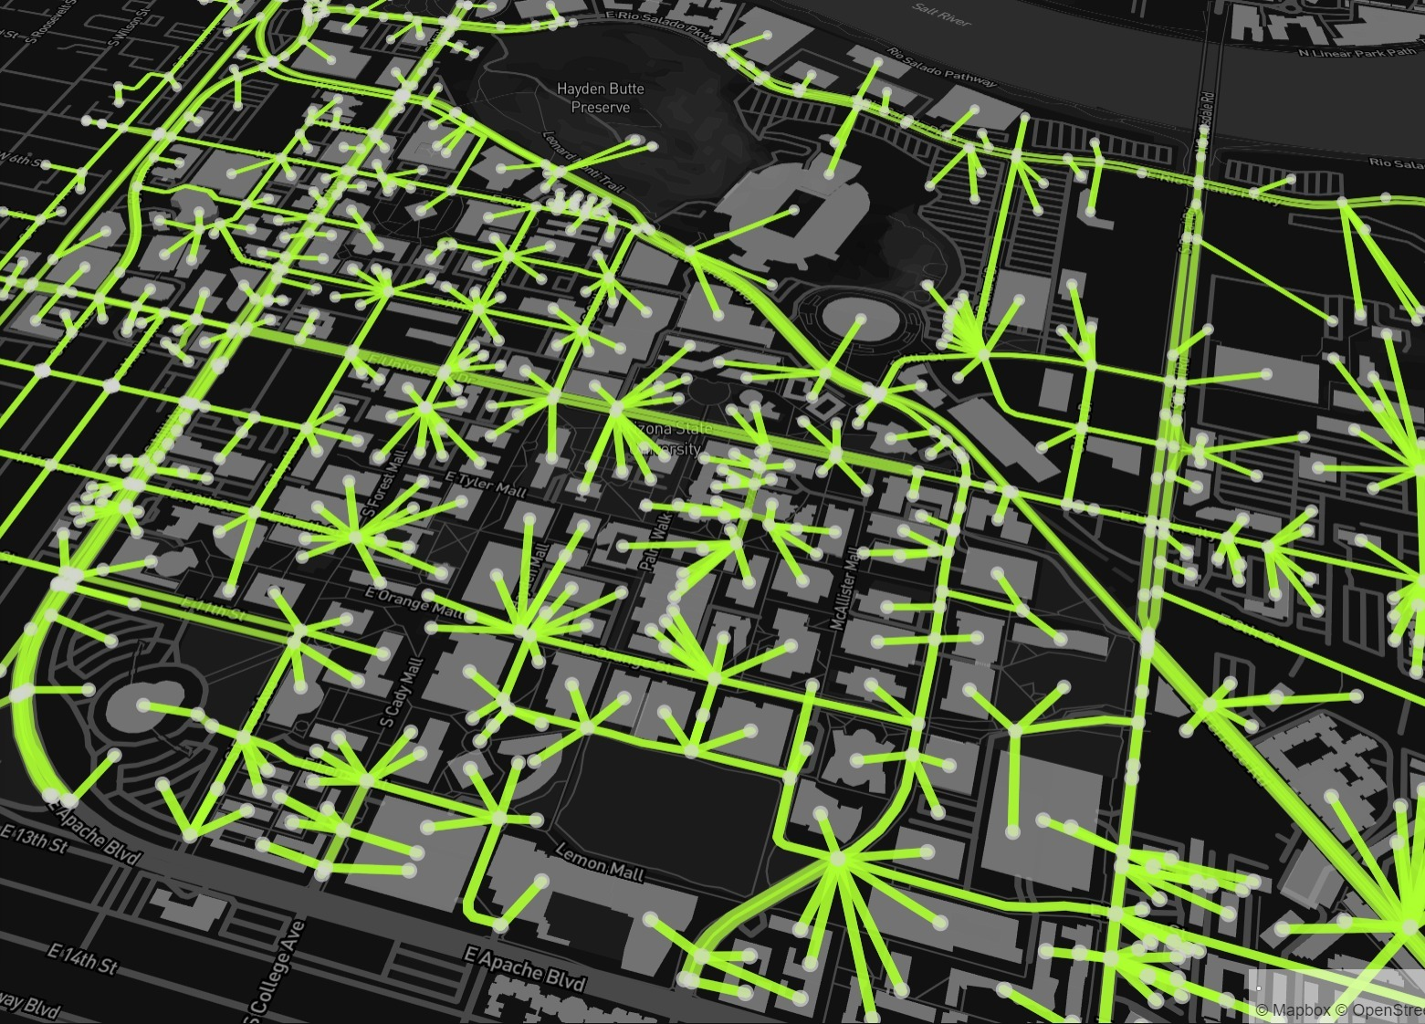

Sample node and link files for the above Arizona State University campus can be found at [here](https://github.com/asu-trans-ai-lab/integrated_modeling_GMNS/tree/main/examples/university_campus/Arizona_State_University). You can contribute your data set for other beautiful [university campuses](https://github.com/asu-trans-ai-lab/integrated_modeling_GMNS/tree/main/examples/university_campus/Arizona_State_University). If you are interested in large-scale network modeling, please fetch the [state-by-state transportation network data](https://github.com/asu-trans-ai-lab/integrated_modeling_GMNS/tree/main/examples/United_States_network/motorway/states) in the United States, in four different layers (motorway, trunk, primary and secondary roads). The network data are converted from Openstreet map to GMNS format using the [OSM2GMNS](https://pypi.org/project/osm2gmns/) python package our team develop.

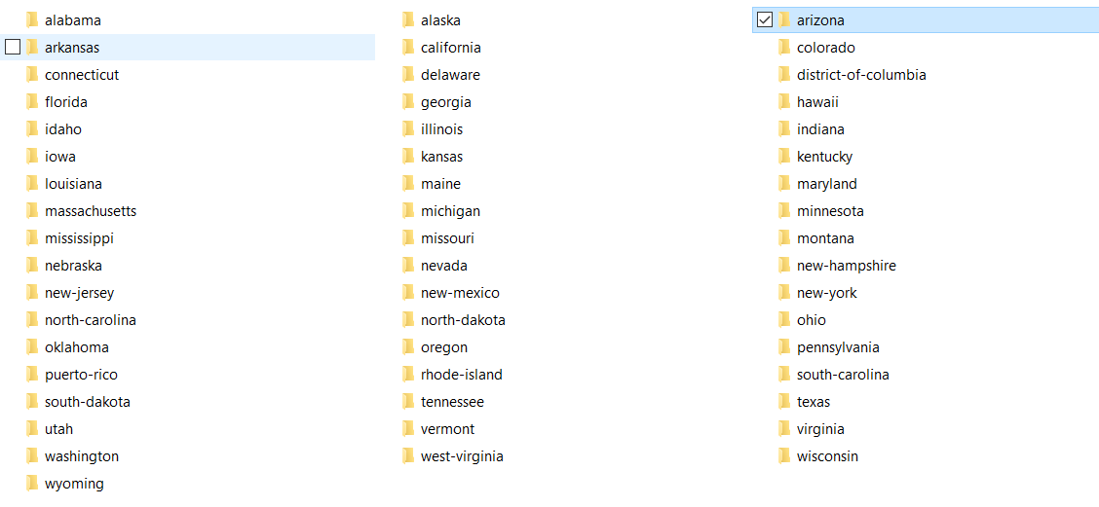

Categories of OpenStreetMap road network: Source: https://wiki.openstreetmap.org/wiki/Map_features

|  |  |  |
| --- | --- | --- |
| Motorway | A restricted access major divided highway, normally with 2 or more running lanes plus emergency hard shoulder. Equivalent to the Freeway, Autobahn, etc. | media/d722abf7b9b28d4e47aeccbd6e315c7b.jpeg Auckland Northern Motorway, New Zealand |
| Trunk | The most important roads in a country's system that aren't motorways. (Need not necessarily be a divided highway.) | media/947dc529e247051bb6b672c736e0d19f.jpeg L3005, Eschborn, Germany |
| Primary | The next most important roads in a country's system. (Often link larger towns.) | media/2850f658b788a3438b40f3299da80fc3.jpeg Hunsrückhöhenstraße, Kappel, Germany |
| Secondary | The next most important roads in a country's system. (Often link towns.) | media/b63aee436fb6076edeedf455d11a3c54.jpeg L134, Meyenburg, Schwanewede, Germany |

Our team is devoted to developing enterprise grade open-source tools for transportation modeling, in a broader context of computational transportation science. Please visit our website for integrated Analysis, Modeling and Simulation ([AMS](https://github.com/asu-trans-ai-lab/integrated_modeling_GMNS)) and related [FHWA AMS data hub effort](https://www.fhwa.dot.gov/publications/research/operations/13036/004.cfm).

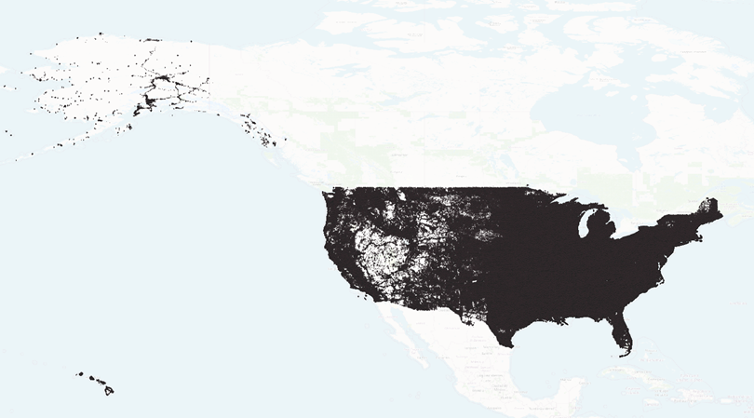

Using [ASU research computing facility](https://cores.research.asu.edu/research-computing/about), we also create an entire U.S. driving network from OpenStreetMap with 20 million nodes. The multi-modal network of ASU Tempe Campus can be found [here](https://github.com/asu-trans-ai-lab/GTFS2GMNS/tree/main/walk_and_bike/Tempe-bike) ([Walk](https://github.com/asu-trans-ai-lab/GTFS2GMNS/tree/main/walk_and_bike/Tempe-walk): red; [Bike](https://github.com/asu-trans-ai-lab/GTFS2GMNS/tree/main/walk_and_bike/Tempe-bike): green)

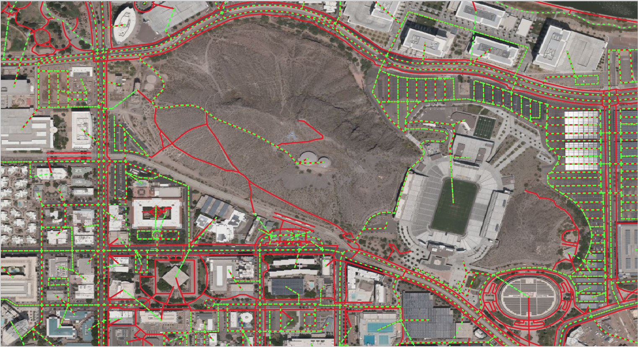

Please join us at smartcityplanning.slack.com to volunteer, or provide comments to our ASU Trans+AI [team members](mailto:xzhou74@asu.edu).